

A Project Report on,
Accessible Data Visualization: Colorblind-Friendly Visual Encodings for Complex Heatmaps and Spatial Maps
By,
Nirmitee Chavan
(SRN: 31242285)
Project No : 1
Guided By
Dr. Anupriya Kamble

Course Name: Research Methedology
For the Programme
B.Sc. - COMPUTER SCIENCE
Third Year
In the Year
2026-27

Pursued in
Department of Computer Science
Faculty of Science & Technology
Vishwakarma University, Pune

CERTIFICATE
This is to certify that the work incorporated in the Project entitled “Accessible Data Visualization: Colorblind-Friendly Visual Encodings for Complex Heatmaps and Spatial Maps”submitted to Vishwakarma University, Pune by Nirmitee Chavan for the completion of the course Research Methedology was carried out by him/her under my supervision in the Department of Computer Science, Faculty of Science and Technology, Vishwakarma University, Pune, Maharashtra, India. This work was not previously submitted by him/her to this or any other University for the award of any Degree, Diploma, Associateship or any other similar title.

Place: Pune Dr. Anupriya Kamble
Date: Course Coordinator

DECLARATION
I hereby declare that the present research work in the form of project report
entitled “Accessible Data Visualization: Colorblind-Friendly Visual Encodings for Complex Heatmaps and Spatial Maps”., is an original work carried out by me under the guidance of Dr.Anupriya Kamble, Assistant Professor, Department of Computer Science, Faculty of Science and Technology, Vishwakarma University, Pune, Maharashtra, India for the completion of the course name Research Methedology
I further declare that to the best of my knowledge the project work does not
contain any part of any work, which has been submitted for the award of any
Degree, either in this University or any other University / Deemed University
without proper citation.

I further declare that the material referred from other sources has been
duly acknowledged in the project report.

Place: Pune
Date:

ABSTRACT
Colour is a widely used visual encoding for communicating quantitative information in heatmaps, spatial maps, and scientific images. However, conventional rainbow and red–green colour palettes can create perceptual inconsistencies and accessibility barriers for people with colour vision deficiencies. These limitations may affect the interpretation of scientific data, particularly when colour differences represent important numerical variations, boundaries, or patterns.
This project investigates accessible colour encoding strategies for complex heatmaps and spatial maps, with emphasis on palette selection and readability for protanopic and deuteranopic users. The study considers sequential colour palettes such as Viridis and Cividis, along with suitable diverging palettes for data varying around a meaningful reference value. A Python-based workflow using Seaborn and Matplotlib is proposed to generate visualizations and compare palette characteristics.
Numerical datasets and medical thermal-image-style intensity data can be represented as heatmaps to examine whether patterns, gradients, and regions remain distinguishable under different colour vision conditions. The project aims to develop a practical evaluation workflow and an accessible visualization prototype. The expected outcome is a set of recommendations for selecting colour encodings that improve perceptual readability and reduce the possibility of misinterpretation. Simulation-based inspection will be treated as a preliminary assessment, while testing with people who have colour vision deficiencies would be necessary for stronger usability conclusions.
.

INDEX
Sr. No. | Content | Pg. No.
1. | Introduction | 6
 |  | 6
  1.1 Objective
 |  | 6
  1.2 | Novel Idea
 |  | 6
  1.3 | Significance
 |  | 6
  1.4 | Specifications
2. | Literature Survey | 7
3. | Methodology | 8
  Data Preparation and Palette Selection
  3.2 | Visualization Generation
  3.3 | Colour Vision Deficiency Assessment
  3.4 | Evaluation Criteria
4. | Implementation | 9
  System Workflow
  4.2 | Web Interface and Modules
  4.3 | Expected Output
5. | Conclusion and Future Scope  5.1 Conclusion  5.2 Result | 10
  5.3 | Future Scope
  5.4 | References

1. Introduction
Data visualization is an essential technique for analyzing and communicating complex information. It converts numerical data into visual forms such as charts, heatmaps, and maps, allowing users to identify trends, patterns, relationships, and outliers. Colour is particularly useful for representing continuous values because it can encode intensity, magnitude, and categories in a compact form.
In heatmaps, colour differences are used to display the values of individual cells, while spatial maps use colour to represent measurements associated with geographical or image regions. In scientific and medical visualization, colour may represent temperature, intensity, density, or other quantitative measurements. The selection of an appropriate colour palette is therefore important for accurate interpretation.
Despite its usefulness, colour-based visualization can create barriers for people with colour vision deficiencies. Protanopia and deuteranopia affect the perception of red–green colour differences. As a result, colour combinations that appear distinct to users with typical colour vision may appear similar to some users with these conditions. This may obscure important patterns, boundaries, or variations in the data.
Traditional rainbow colour maps are frequently used in scientific visualizations because they contain multiple hues. However, their colour transitions may not correspond consistently to changes in numerical values. Some colours may appear more prominent than others, creating misleading emphasis. Such issues can affect the interpretation of complex heatmaps and spatial maps.
This project investigates colour palette selection for accessible heatmaps and spatial maps. It considers perceptually informed palettes, including Viridis and Cividis, as well as diverging palettes appropriate for data that varies around a meaningful midpoint. The project proposes a Python-based process using Seaborn and Matplotlib to create visualizations and examine their readability under simulated protanopic and deuteranopic conditions.

1.1 Objective
The primary objective of this project is to evaluate colour palette selection theories and determine how Viridis, Cividis, and suitable diverging palettes support the readability of complex heatmaps and spatial maps for protanopic and deuteranopic users.
The specific objectives are:
- To study the perceptual properties of commonly used colour palettes.
- To understand the accessibility challenges associated with conventional rainbow and red–green colour maps.
- To generate heatmaps and spatial-style visualizations using Python, Seaborn, and Matplotlib.
- To compare Viridis, Cividis, and suitable diverging palettes using consistent datasets and visualization settings.
- To examine the readability of selected palettes under simulated protanopic and deuteranopic vision.
- To evaluate the preservation of data patterns, boundaries, gradients, and high- and low-value regions.
- To develop practical recommendations for selecting accessible colour encodings for scientific and medical-style visualizations.

1.2 Novel Idea
The proposed work combines palette comparison, heatmap generation, spatial-style visualization, and colour vision deficiency assessment into a single research workflow. Instead of recommending a colour palette based only on its visual appearance, the project evaluates palette suitability according to the type of data and the visualization task.
Sequential palettes are considered for data that progresses from low to high values. Diverging palettes are considered when data varies around a meaningful centre, such as a baseline, reference temperature, or zero value. This distinction is important because different data structures require different visual encoding strategies.
The project proposes applying multiple palettes to the same dataset while maintaining consistent value ranges, labels, and visualization settings. This enables a more meaningful comparison of the resulting visual representations.
The novel aspect of the project is the integration of palette selection and colour vision deficiency assessment into an accessible visualization workflow focused on complex heatmaps and spatial maps. The proposed approach can help users identify colour encodings that preserve important visual information under different viewing conditions.

1.3 Significance
Accessible data visualization supports inclusive communication of scientific information. A palette that preserves perceptual differences can help users recognize high and low values, identify spatial patterns, and interpret heatmap regions more reliably.
This project is significant because colour is often the primary visual encoding in scientific and medical-style images. If important values are represented using confusing colour combinations, users may have difficulty identifying meaningful patterns or interpreting changes in the data.
The project can benefit students, researchers, data analysts, and developers who prepare scientific reports, dashboards, heatmaps, and spatial visualizations. It also encourages the use of accessible colour palettes during the design stage rather than treating accessibility as a later correction.
In medical or thermal-image contexts, accessible colour encoding may improve the presentation of information. However, the proposed project is intended for visualization research and does not replace clinical interpretation, validated diagnostic tools, or medical decision-making systems.

1.4 Specifications

Software Requirements
- Programming Language: Python
- Visualization Libraries: Seaborn and Matplotlib
- Data Processing Libraries: NumPy and Pandas
- Web Interface: HTML, CSS, JavaScript
- Optional Backend Framework: Flask
- Development Environment: Visual Studio Code
- Data Formats: CSV files and numerical matrices
- Colour Palette Families: Viridis, Cividis, and selected diverging palettes
- Assessment Conditions: Typical colour vision, simulated protanopia, and simulated deuteranopia

Hardware Requirements
- Standard laptop or desktop computer
- Minimum 4 GB RAM
- Adequate storage for datasets and visualization outputs
- Modern web browser
- No specialized hardware sensor is required for the proposed software-based evaluation

Functional Requirements
The proposed system should allow users to:
- Upload or load numerical datasets.
- Select a visualization type.
- Choose from multiple colour palettes.
- Generate heatmaps and spatial-style visualizations.
- Compare palette outputs using consistent data ranges.
- Inspect visualizations under selected colour vision deficiency simulations.
- View and save generated visualization outputs for analysis.

2. LITERATURE SURVEY
Research over the past decade has established that colour-map selection influences the accuracy, readability, and accessibility of scientific visualization. Data visualization techniques such as heatmaps, spatial maps, scientific images, and statistical graphs commonly use colour to represent numerical values, identify patterns, and communicate relationships between data variables. Traditional rainbow colour maps are widely used because they contain a broad range of visually distinct hues. However, their colour transitions do not always correspond to uniform changes in the underlying data. Crameri, Shephard, and Heron (2020), in “The Misuse of Colour in Science Communication,” discussed how inappropriate colour-map selection can distort scientific data representation and reduce accessibility for people with colour vision deficiencies. Their work highlighted that rainbow colour maps may introduce artificial boundaries, exaggerate selected variations, or hide meaningful patterns. These concerns are important in heatmaps and spatial maps, where colour often carries the primary quantitative meaning. The study supports the use of perceptually informed palettes whose visual progression corresponds more consistently to numerical change.
Nuñez, Anderton, and Renslow (2018), in “Optimizing Colormaps with Consideration for Color Vision Deficiency to Enable Accurate Interpretation of Scientific Data,” investigated the development of colour maps that support interpretation by viewers with typical and colour-deficient vision. Their work introduced Cividis, a colour map designed to maintain a consistent brightness progression and perceptual uniformity. The study emphasized that palette design should account for how colour differences are perceived under red–green colour vision deficiency rather than assuming that a palette clear to one group will be equally clear to all viewers. Cividis was developed to provide a more consistent representation of quantitative information for viewers with and without common red–green colour vision deficiencies. This research is relevant to quantitative heatmaps, where subtle colour differences can represent meaningful data changes.
Research on scientific colour mapping has further emphasized perceptual uniformity, luminance, and the consistency of colour transitions. Perceptually even gradients can reduce the likelihood that some values appear more prominent than others simply because of a palette’s hue or brightness structure. Viridis and Cividis are commonly used sequential palettes because they provide a progression in lightness and are designed to remain interpretable across a range of colour vision conditions. Grayscale inspection can also reveal whether a visualization relies excessively on hue. These principles are particularly relevant when a heatmap contains many adjacent cells or small value differences. The use of a consistent lightness progression can help maintain the visual ordering of numerical values and support more reliable interpretation.
Research on accessible spatial visualization has also addressed the importance of colour selection in scientific maps. Rocchini et al. (2023), in “Scientific Maps Should Reach Everyone: The cblindplot R Package to Let Colour Blind People Visualise Spatial Patterns,” presented an R-based approach for improving the accessibility of scientific maps. Their work focused on enabling users to consider colour vision deficiency and inspect spatial patterns in more accessible ways. Spatial maps often use colour to represent geographical variation, environmental measurements, or regional statistics. Unsuitable colour ramps can make neighbouring areas difficult to distinguish and can hinder the identification of spatial variation. This research demonstrates that accessibility considerations should extend beyond standard charts to map-based visualizations.
Rocchini et al. (2024), in “Under the Mantra: ‘Make Use of Colorblind Friendly Graphs’,” emphasized the importance of adopting accessible palettes and avoiding confusing red–green combinations. Complex visualizations may use several layers, regions, or variables, and colour alone may not be sufficient to distinguish them. The literature therefore supports the use of additional visual encodings such as lightness, texture, pattern, shape, and boundary outlines. These techniques can provide redundant cues and help preserve the meaning of visual elements when hue distinctions are reduced. The findings are relevant to complex spatial maps and heatmaps in which multiple features may overlap or appear close to one another.
Protanopia and deuteranopia are red–green colour vision deficiencies that can make some colour combinations difficult to distinguish. In scientific and medical visualization, this may affect the interpretation of intensity gradients, categories, and boundaries. Studies on Cividis and colour-blind-friendly maps support the use of colour vision deficiency simulation as an initial design assessment. Nevertheless, simulated appearance is not a complete substitute for user evaluation, because individual perception and task performance may vary. A comprehensive accessibility assessment should combine palette analysis, simulated conditions, and, where feasible, testing with people who have colour vision deficiencies.
The reviewed literature indicates that palette performance depends on the visualization type, data range, contrast, and task. Sequential palettes are generally appropriate for values that increase from low to high, while diverging palettes are useful when values move in two directions from a meaningful midpoint. A palette suitable for a simple image may not necessarily provide the same clarity in a dense heatmap or spatial map. This project therefore proposes a comparative evaluation of Viridis, Cividis, and suitable diverging palettes using Python-based visualizations, with attention to readability under simulated protanopic and deuteranopic conditions. The expected contribution is a practical workflow and recommendations for accessible colour encoding in complex scientific visualizations.

3. METHODOLOGY
The proposed methodology follows a structured workflow consisting of literature analysis, data preparation, visualization generation, palette selection, colour vision deficiency simulation, and comparative assessment. The workflow is designed to ensure that each palette is applied to the same dataset and uses a consistent value range, allowing the resulting visual differences to be compared meaningfully.
The methodology focuses on evaluating colour encoding rather than changing the underlying numerical information. The original data values will be preserved, and the visualization settings will be maintained consistently across palette comparisons.

3.1 Data Preparation and Palette Selection
The project may use numerical datasets in CSV format and matrix-based data derived from thermal-image-style samples. The input data will be inspected for missing values, non-numeric fields, inconsistent dimensions, and outliers.
Numerical columns will be selected for visualization, and data normalization may be applied when comparison across different scales is required. For thermal intensity data, the original numerical values and their range should be retained so that the colour map does not change the underlying information.
The evaluation will include Viridis and Cividis as sequential palettes and one or more diverging palettes, such as Coolwarm or a red–blue diverging map, where a central reference value is meaningful.
Each palette will be applied to the same input data. Sequential palettes will be assessed for monotonic progression and the ability to represent increasing intensity. Diverging palettes will be assessed for clear separation on both sides of the midpoint and for avoiding misleading emphasis.

3.2 Visualization Generation
Python libraries Seaborn and Matplotlib will be used to generate heatmaps and spatial-style intensity maps. Axis labels, colour bars, titles, and value ranges will be kept consistent across palette comparisons.
The visualizations will be generated at a suitable resolution for inspection and inclusion in the project report. A prototype interface may allow users to select the visualization type and palette and render the corresponding chart.
Heatmaps will be used to represent numerical values through colour-coded cells. Spatial-style maps will represent intensity values across a two-dimensional region. These visualizations will provide a basis for comparing the readability of different colour palettes.

3.3 Colour Vision Deficiency Assessment
The generated visualizations will be examined under typical colour vision and simulated protanopic and deuteranopic conditions using an appropriate simulation approach.
The assessment will consider whether important gradients, boundaries, clusters, and high- and low-value regions remain visually distinguishable. Simulation outputs will be used as a screening step to identify potential accessibility issues.
Simulation-based assessment will not be interpreted as definitive evidence of usability for all individuals with colour vision deficiencies. Further user-based testing would be required to establish the practical accessibility of the proposed visualizations.

3.4 Evaluation Criteria
The comparative assessment will consider the following criteria:
- Perceptual Readability: Whether the visualization communicates numerical values clearly.
- Contrast: Whether neighbouring values and regions remain distinguishable.
- Gradient Continuity: Whether colour transitions represent numerical changes consistently.
- Pattern Preservation: Whether important spatial patterns remain visible.
- Visibility of Extrema: Whether high and low values can be identified.
- Accessibility: Whether the palette remains distinguishable under simulated protanopic and deuteranopic vision.
- Interpretability: Whether the visualization supports meaningful analysis without creating misleading visual emphasis.
Where possible, quantitative measures such as luminance progression or perceptual colour distance may complement visual inspection. A consistent evaluation protocol will be used for all palettes. The results will be summarized in comparison tables and visual examples.

4. IMPLEMENTATION
The implementation is planned as a Python-based visualization workflow, with an optional web interface for interactive palette exploration. The backend will use Python to prepare the data and generate visual outputs, while Seaborn and Matplotlib will provide the heatmap and spatial-style plotting functionality.
Pandas and NumPy will support dataset loading, numeric selection, cleaning, and transformation. The proposed system will allow users to visualize numerical data using different colour palettes and compare the outputs for accessibility.

4.1 System Workflow
The proposed system follows the workflow below:
- Input dataset is loaded from a CSV file or numerical matrix.
- Data is checked and prepared for visualization.
- User selects a visualization type and colour palette.
- The Python plotting module generates the heatmap or spatial intensity map.
- The output is inspected in typical and simulated colour vision conditions.
- The palette is evaluated against readability and pattern-preservation criteria.
- Visual examples and observations are recorded for the final report.
This workflow supports a consistent comparison of colour palettes and enables the evaluation of their suitability for different visualization tasks.

4.2 Web Interface and Modules
The proposed web interface can provide a sign-up page, login page, dashboard, and visualization workspace. Authentication allows a user to access the visualization module after creating an account.
The dashboard presents the project objective and available functions. The visualization workspace provides palette selection, dataset upload, and rendering controls. A chart preview displays the generated output and its colour scale.
The major modules of the proposed system are:
1. User Authentication Module
This module provides sign-up and login functionality. Users can create accounts and access the visualization workspace after authentication.
2. Dashboard Module
The dashboard provides an overview of the project, its objectives, and the available visualization features.
3. Dataset Upload Module
This module allows users to upload numerical datasets in CSV format. The system can inspect the dataset and identify numerical values suitable for visualization.
4. Palette Selection Module
Users can select palettes such as Viridis, Cividis, and suitable diverging palettes. The selected palette is applied to the input data.
5. Visualization Module
This module generates heatmaps and spatial-style intensity maps using Python, Seaborn, and Matplotlib.
6. Accessibility Assessment Module
This module supports the examination of visualization outputs under selected colour vision deficiency simulations. The outputs can be compared to identify possible readability issues.
The interface is intended as an academic prototype for demonstrating palette comparisons. It does not claim to provide a clinically validated medical-image analysis system.

4.3 Expected Output
The implementation is expected to produce a collection of comparable heatmaps and spatial-style visualizations using Viridis, Cividis, and selected diverging palettes.
Outputs will be examined for differences in visual continuity, contrast, and the preservation of meaningful data patterns. A summary of observations will be used to identify palettes that appear better suited to particular data types and visualization tasks.
The final output will include the prototype workflow, generated figures, comparative findings, and recommendations for accessible visualization. The project will demonstrate how palette selection can influence the readability of scientific data and how accessibility can be considered during visualization design.

5. CONCLUSION AND FUTURE SCOPE

5.1 Conclusion
This project addresses the accessibility challenges associated with colour-based scientific visualization, particularly for individuals with protanopia and deuteranopia. The literature indicates that conventional rainbow and red–green palettes can introduce perceptual problems, while perceptually informed colour maps such as Viridis and Cividis provide useful alternatives for quantitative data.
The proposed work evaluates sequential and diverging palettes in complex heatmaps and spatial maps using a Python-based workflow with Seaborn and Matplotlib. By comparing visualization outputs under typical and simulated colour vision conditions, the project aims to identify palette characteristics that support clearer representation of numerical patterns.
The intended result is an accessible visualization prototype and a set of practical palette-selection recommendations. The project emphasizes the importance of selecting colour encodings according to data characteristics and visualization requirements.
The conclusions will be limited to the tested datasets and evaluation methods. Simulation alone cannot establish full user accessibility or clinical validity. Future user-based studies would be necessary to confirm the effectiveness of the proposed palette-selection strategies.

5.2 Future Scope
The project can be extended in several ways to improve its evaluation and practical application.
Future work may include usability testing with people who have protanopia or deuteranopia and comparing task performance across different colour palettes. Additional colour vision deficiency types and accessibility conditions can also be included.
More datasets, including real-world scientific and medical thermal datasets, may be evaluated after confirming appropriate permissions and data handling. The system may be extended with automated palette recommendations based on data semantics, perceptual colour-distance metrics, and luminance progression.
The web application could also be expanded with interactive side-by-side comparisons, saved experiments, user-specific settings, and downloadable reports. Further work may investigate redundant encodings such as texture, contour lines, and labels where colour alone is insufficient.
These improvements may support a more comprehensive and evidence-based framework for accessible scientific visualization.
5.3 Result

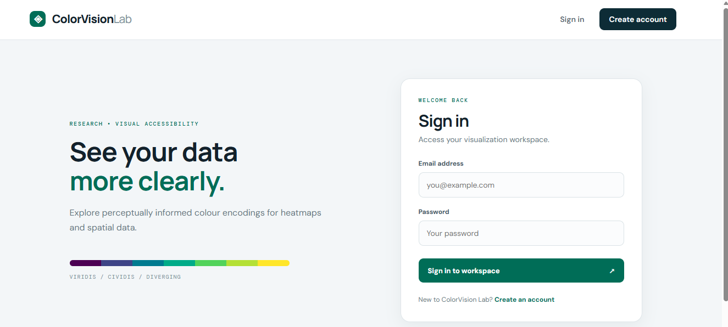
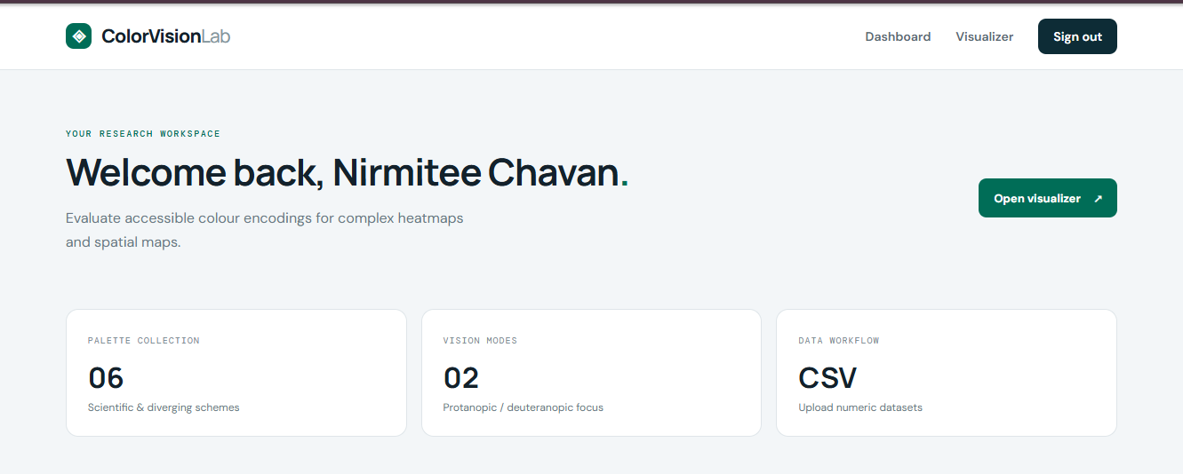
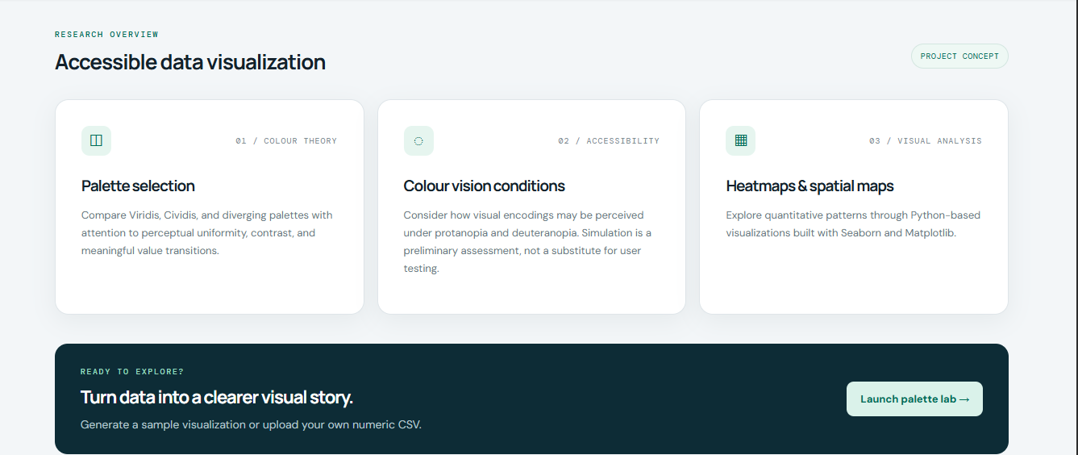

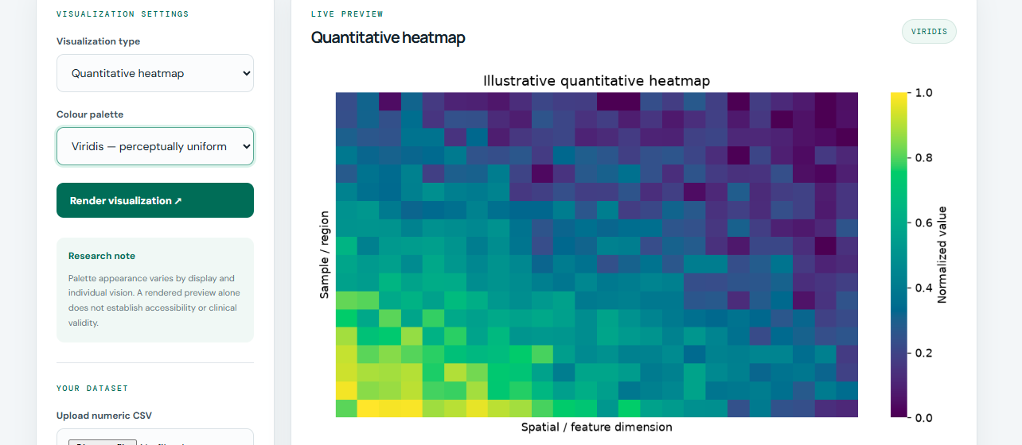

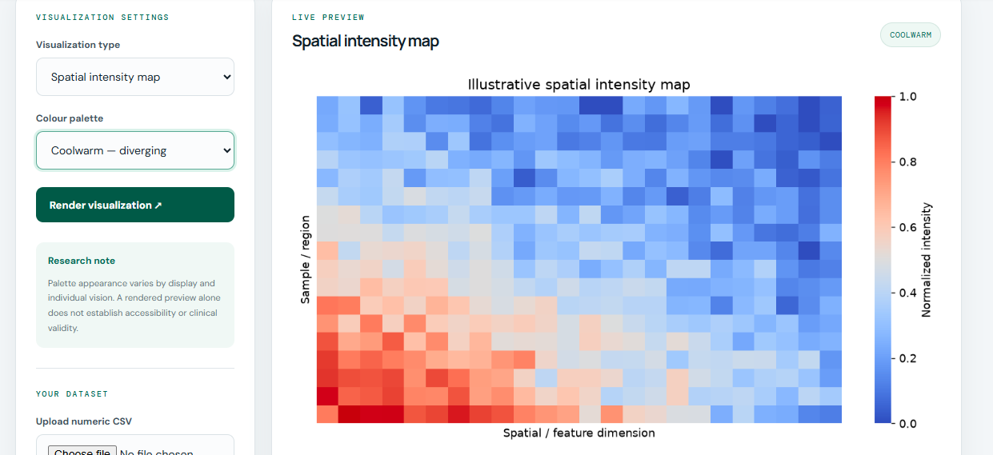

REFERENCES
[1]Crameri, F., Shephard, G. E., & Heron, P. J. (2020). The misuse of colour in science communication. Nature Communications, 11, 5444. https://doi.org/10.1038/s41467-020-19160-7
[2]Nuñez, J. R., Anderton, C. R., & Renslow, R. S. (2018). Optimizing colormaps with consideration for color vision deficiency to enable accurate interpretation of scientific data. PLOS ONE, 13(7), e0200331. https://doi.org/10.1371/journal.pone.0200331
[3]Okabe, M., & Ito, K. (2008). Color Universal Design (CUD): How to Make Figures and Presentations That Are Friendly to Colorblind People.
[4]Matplotlib Development Team. Choosing Colormaps. Matplotlib Documentation. https://matplotlib.org/stable/users/explain/colors/colormaps.html
[5]Seaborn Development Team. seaborn.heatmap Documentation. https://seaborn.pydata.org/generated/seaborn.heatmap.html

